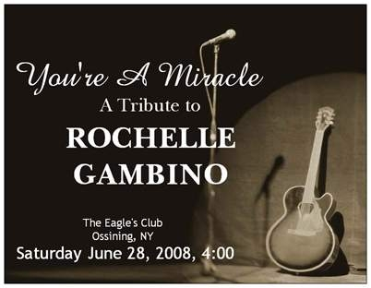
Advertising and Dedication

Journal for the

Rochelle Gambino Tribute
The journal will be a 5 x 7 booklet handed out to all who attend the tribute concert.
This is an excellent opportunity for advertising and networking as we are expecting a large turnout.
The dedications will serve as a remembrance as well as an appreciated donation.
Rochelle Gambino dedicated her life to her music and her family. She wrote, played, and performed her music in the Hudson Valley for 30 years. She passed away suddenly on December 30th, 2007. She was 44. She leaves behind a beautiful 8 year old son, A.J. On June 28th we are having a tribute concert and auction to raise money for his trust fund.

Below are prices and sizes for a journal ad:

Business Card Size; 2 X 3 ½ ($10) $__________________

Full Page; 5 ½ X 7 ½ ($25) $__________________

Payment in form of cash or
checks made out to: “Albert John Vitiello”

Name:________________________ #( )_________________

Tape business card here -----------→
or write your own message for the journal.

Example” We miss you, Rochelle!

Keep Rocking with the Angels
Love, Lilly & Steve

(Full Page ads write “On Back” and place on back of this page)

All ads MUST be submitted by Friday May 16th
Please forward to:
Jackie Bufi
127 Dale Ave~Cortlandt Manor, NY~10567
Any questions, please call: (914)497-1284

